**Hans Archer Dalubatan**

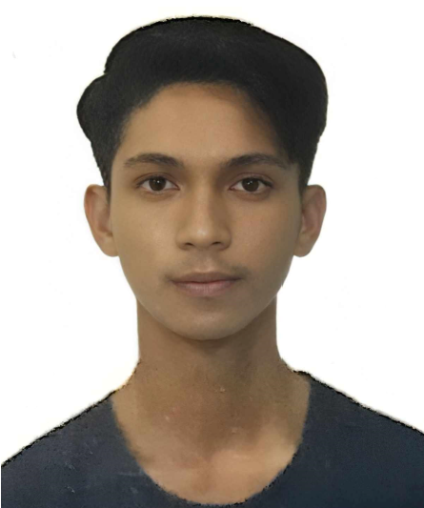

G. Zeta St. Argao, Cebu Philippines **+639936032005/9496265678 dalubatanhans@gmail.com** [**https://github.com/hanz-archer**](https://github.com/hanz-archer)

# Junior Software Developer with solid back-end and front-end skills. Proficient in Git/GitHub, CI/CD using YAML, and deploying applications through GCP Cloud Run and Cloud SQL. Experienced in mapping custom domains and dedicated to creating effective, user-centric solutions while learning DevOps continuously.

# EXPERIENCE zaneCoder, California, United States of America — *Junior Software Engineer*

April 2025 - Present

Design, implement and maintaining scalable web applications and DevOps pipelines on Google Cloud Platform, including Cloud Run, Cloud SQL, and CI/CD automation. Proficiency in building modern, fast, and high-performance front-end applications using Nuxt.js, Next.js, React, and TypeScript. He is an expert in using JavaScript, PHP, and YAML-based workflows for reliable production-grade solutions.  
  
**Philippine Statistics Authority,** Argao Cebu— ***Statistical Researcher***

June 2024 - September 2024

I was tasked with collecting demographic, social, and economic data from households. This data is critical for national planning, development programs, and the formulation of policies aimed at improving the quality of life for Filipinos. My role involved identifying and addressing discrepancies in the data.

**FJR IT Solutions,** Argao Cebu— ***Computer Servicing Intern***

May 2021 - June 2021

Provided PC services, such as hardware installation, software setup, and maintenance. This hands-on experience greatly enhanced my technical skills and deepened my understanding of IT solutions. I also installed point-to-point (P2P) WiFi connections, ensuring network setups were correctly implemented for home and small business use.

# EDUCATION

**Cebu Technological University,** Argao Cebu — *Bachelor of Science in Information Technology* Dean’s Lister

Kwentas Klaras Digital Project Management Information System v1.0 Developer

June 2021 – Present

**Argao National High School,** Argao Cebu — *Senior High School, Information Communications Technology Strand*

June 2019 - May 2021

With Honors

# PROJECTS

**Kwentas Klaras Digital Project Management Information System** — *Developer*

The Kwentas Klaras Digital Project Management Information System (PMIS) is a sophisticated yet easy to use platform designed for getting public sector projects by the Local Government Unit (LGU) of Boljoon. The project calls for planning, tracking and reporting on projects, with tools available to local government officials, stakeholders, and team members who are executing the project.

**Visual Studio Code Extension: Live Collaboration (Code ta Bai!)** — *Developer*

A Typescript based VS Code extension for real-time collaboration, allowing multiple users to edit the same file simultaneously. It syncs changes across instances using a unique document ID, making collaborative coding seamless.

**Visual Studio Code Extension: Github Workflow Generator** — *Developer*

Automatically generate GitHub Actions powered by Typescript, Automating workflow files for popular project types like Django, Python, HTML/CSS with Firebase, and PHP. Streamline CI/CD.

**Visual Studio Code Extension: Django Setup** — *Developer*

This tool assists in creating a Django project with a virtual environment, installing dependencies, and setting up a Python-based development environment. It automates the process of generating a project and app structure, saving time for developers starting new Django applications.

**Vite + React Automation Script** — *Developer*

A batch script designed to automate the initial setup for a MERN (MongoDB, Express, React, Node.js) stack project. The script handles the creation of a folder structure, initializes a Vite React project for the frontend, sets up Tailwind CSS, and creates placeholder files and directories to streamline development.